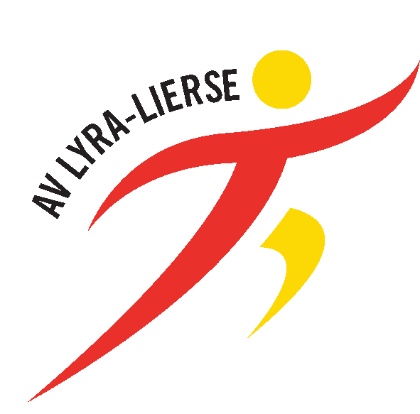

Mobile : +32 486 72 07 84
E-mail: AVLL@atletiek.be
BONUS FLANDERS CUP ‘Memorial Jos Verstockt’ 2023
+ Naam / Nom /Name : …………………..………………….…..…………………………………………….…………………………
+ Straat/Rue/Street: ……...…………………………………………………………………………………………………….…………
+ Postcode/Code Postale: ………………….. + Stad/Ville/City : …………………………… ……Country : ………………………
+ E-mail : ………………………..………………@…………..…………….…………………………..…
+ Mobile:…………………………………………..
+ Geb.jaar/An.naissance/YoB: ……………………………………………...……
+ Discipline/Event : …………………………….………………………………….
+ Prestatie/Prestation/Result: ………………………..……………………………..…… + Wind/Vent (m/s): …….……………..
+ IBAN Bank Code* : ………………………………………………………………………………………………….…….
- BIC Code** : ……………………………………………………………………………………………..…………
* The IBAN Code (International Bank Account number) is an international standard bank account identifier
** The Bank Identifier (BIC Code) is a unique address of 8 till 11 alphanumeric signs

+ Controle : OK / NIET OK - Betaald/Payé/Payed op/le/on : ……………………………………..……………………

Privacy policy: AV Lyra-Lierse declares to only use these personal data in order make payments to the athletes and for legal accounting matters
These data are saved by the club for a maximum of one year. For more information, see the full privacy statement at the website of www.aclyra.com

